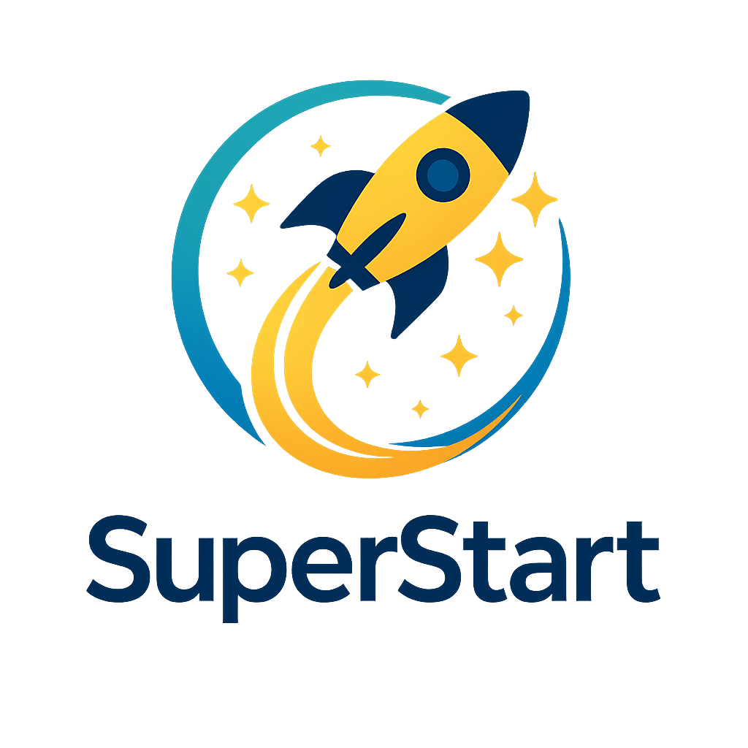

SuperStart Mentorship Programme
Overview of the SuperStart Mentorship Programme
Early-career support at FirstRand was not always consistent. Some new joiners landed in teams where they received strong guidance, frequent check-ins, and a clear sense of how to succeed. Others did not — not because of capability or effort, but because of differences in team context, manager capacity, and workload. The result was an uneven early-career experience shaped more by luck than by design.
SuperStart was created as a direct response to this known gap in the First Job experience. The problem was already visible and acknowledged: early development and support were too dependent on circumstance. SuperStart is the intentional solution that emerged from that brief.
SuperStart is FirstRand’s early-career mentorship programme, designed to support and shape the journeys of new and early-in-role employees across the Group. Rather than leaving early development to informal or manager-dependent support, the programme embeds structured mentorship from the outset, recognising that how people start their careers has a lasting impact on confidence, engagement, and long-term success.
At its core, SuperStart offers a guided mentorship journey that goes beyond technical delivery. The programme takes a holistic approach to early-career development, focusing on confidence, self-awareness, emotional intelligence, and belonging alongside role performance. Through structured reflection and guidance, participants build personal and professional confidence, gain insight into how they show up at work, and learn to navigate organisational expectations and norms more effectively.
By formalising peer mentorship as part of the early-career experience, SuperStart positions support and development not as optional or incidental, but as a foundational element of how FirstRand invests in its future talent.

Who SuperStart Is and What It Aims to Achieve
  - Purpose of SuperStart
The purpose of SuperStart is to ensure that access to early-career guidance at FirstRand is not influenced by team, role, manager capacity, or confidence level. The programme exists to create a more equitable and consistent early-career experience for employees entering the organisation, particularly those in their first professional roles.
  - SuperStart provides a shared mentorship structure that spans teams and business areas, reducing reliance on informal, manager-dependent support. By doing so, it ensures that early-career employees receive a comparable quality of guidance regardless of where they are placed in the organisation. This consistency supports smoother transitions into role expectations, workplace norms, and ways of working.
  - Through its structured, peer-led approach, SuperStart addresses the uncertainty and anxiety commonly experienced by first-jobbers and replaces it with clarity, reassurance, and trusted support. The outcome is not only improved short-term adjustment, but stronger long-term career readiness, resilience, and sustained confidence across the early-career population.

Origin of the SuperStart Programme
The SuperStart programme originated from a simple but important question: “What if every early career hire had one consistent, structured source of guidance focused on their growth, not just their performance?” This question highlighted a gap in the early career experience and became the foundation for rethinking how new talent is supported at FirstRand.

Historically, early career experiences across FirstRand varied significantly. Some new joiners benefited from strong mentorship and consistent support, while others struggled—not because of a lack of ability, but because the quality of support depended heavily on individual managers or team cultures. This inconsistency created uneven outcomes and unnecessary uncertainty for employees at the start of their careers.

In response to this gap, the 2025 Graduate Mentorship Portfolio was tasked with reimagining early career support across the organisation. This work led to the creation of SuperStart as a deliberately designed, scalable mentorship offering.
SuperStart was intentionally designed to create consistency, reduce uncertainty, and help new joiners find their footing faster. By shifting early career support from informal and uneven to structured and intentional, the programme lays a stronger foundation for confidence, growth, and long-term success.

Founding Team and Accountability
  - We should absolutely name people, but the focus should be what the project demonstrates, not just who contributed. Right now it reads more like credits than a business case.
  - Lead with the key point: SuperStart was designed, built, and handed over by two successive graduate cohorts, demonstrating the ownership and sustainability the programme is built on. Then name the contributors afterwards.
  - Initial Team
The mentorship initiative was founded and led by members of the 2025 Graduate Programme: Nathan Ngqwebo, Noluthando Buthelezi, Malamba Lavhengwa, and Andiswa Mashimbye, operating under the Graduate Executive Committee’s Mentorship Portfolio. The programme was developed with guidance and support from the following contributors: Ntsiki Morrison, Mosa Seloane, and Zaheer Ismail, whose experience and insight helped shape its design and direction. Established to support First Job entrants, the initiative focuses on providing clarity, confidence, and a sense of belonging as First-Jobbers begin their careers. Over the past year, the founding team designed, implemented, and sustained the programme through their graduate tenure and into their second year, demonstrating continuity of ownership, strong commitment, and a lasting contribution to early-career development and organisational culture.

Why SuperStart was created

SuperStart was created in response to a clear gap identified in the early career experience within the First Job Programme at FirstRand. While talent entered the organisation with strong potential, their early experiences were often shaped by inconsistent levels of support and guidance.

Several key challenges were identified across the early career journey.
- Limited structured support: Many first jobbers entered the organisation without access to a consistent or formal support structure to help them transition into the workplace.
- Manager dependent mentorship: Mentorship experiences varied widely and depended heavily on individual managers or team environments rather than on a shared organisational approach.
- Inconsistent onboarding and development: Early onboarding and development experiences differed across business areas, resulting in unequal exposure, guidance, and growth opportunities.
As a result of these challenges, some early career employees began their time at FirstRand feeling unsupported, unseen, and uncertain about their roles, expectations, and long-term growth paths. This uncertainty was not linked to capability, but rather to the absence of intentional early career guidance.

SuperStart was created to directly address these challenges by providing a consistent, intentional mentorship framework. The programme ensures that no young professional enters FirstRand without guidance, connection, and clarity, establishing a stronger and more equitable foundation for confidence, belonging, and long-term career success.

Design Principles

These principles guided every decision made in designing SuperStart and shaped how the programme was built to be fair, scalable, and practical. They establish a clear foundation for how support is delivered, how participants engage, and how the programme sustains impact over time.
- Consistency over ad-hoc support: The programme prioritises a structured and repeatable experience so that every participant receives the same level of support. This approach reduces randomness and dependency on individual managers, creating a reliable and equitable baseline for development.
- Equal access to guidance: SuperStart is designed to ensure that all early-career hires have the same opportunity to learn and grow. Access to guidance is not influenced by team, role, or confidence level, helping to level the playing field across the organisation.
- Shared accountability: Successful outcomes are treated as a joint responsibility. Both mentors and mentees are accountable for progress, engagement, and results, reinforcing balanced ownership rather than placing the burden on one side of the relationship.
- Human-centred, operationally light: The design focuses on real human development and meaningful relationships, while deliberately remaining easy to run. Administrative effort is kept minimal so that energy is spent on people, not process.
- Scalable without losing impact: SuperStart is built to grow across cohorts and departments without becoming diluted or impersonal. As participation increases, the programme maintains its quality, relevance, and personal value.

What SuperStart Is Today
  - A Clear Definition of the Programme
This chapter defines SuperStart in clear, practical terms to ensure a shared understanding of its purpose and structure. By clearly articulating what the programme is and how it works, it removes ambiguity, sets consistent expectations, and creates alignment for participants, mentors, and the organisation.

SuperStart is a structured, time-bound mentorship programme designed to provide early-career hires with consistent guidance through a defined development journey. The programme is focused on progression, helping participants build confidence, capability, and clarity as they move from entry into effective contribution.

- Structured mentorship cycles: The programme operates with a clear start, middle, and end, avoiding open-ended or informal arrangements. This structure creates momentum, supports commitment, and ensures that development feels purposeful and time-bound.
- Joint mentor–mentee onboarding: Both mentors and mentees begin the programme aligned on its purpose, expectations, and boundaries. This shared onboarding establishes clarity from the outset and supports stronger, more effective mentoring relationships.
- Guided development themes: Each phase of the programme is centred on specific growth areas, such as confidence building, skill development, and career navigation. This ensures development is intentional, progressive, and relevant to early-career needs.
- Integrated with talent systems: SuperStart is designed to work alongside existing onboarding, performance, and development processes. Rather than operating in isolation, it strengthens and complements current talent systems to create a cohesive employee experience.

End-to-End Mentorship Journey
  - How the Programme Works in Practice
This chapter explains how SuperStart operates end-to-end, translating the programme’s principles into a clear, practical flow. The structure is intentionally visible and well-governed, ensuring that the experience is consistent, accountable, and manageable at scale rather than reliant on informal or ad-hoc arrangements.

- Early mentor sourcing: Mentors are identified and confirmed ahead of mentee onboarding. This ensures readiness, avoids last-minute matching, and signals that mentorship is a deliberate and valued commitment rather than an afterthought.
- Formal mentor registration: Mentors formally register their participation, establishing role clarity, expectations, and commitment from the outset. This step supports quality, consistency, and accountability across the programme.
- Mentor–mentee matching: Pairings are based on development needs, relevant experience, and mutual availability. This intentional matching increases the likelihood of productive, meaningful mentoring relationships.
- Joint training and expectation setting: Mentors and mentees are onboarded together to build a shared understanding of goals, cadence, boundaries, and responsibilities. This alignment reduces mismatch and sets a solid foundation for the relationship.
- Structured five-month mentorship cycle: The programme runs over a defined five-month period, supported by regular check-ins, prompts, and development themes. This structure maintains momentum while allowing space for reflection and growth.
- Midpoint and final feedback: Formal reflection points enable course correction, shared learning, and assessment of progress. These milestones support both individual development and continuous improvement of the programme.
- Close-out, reporting, and insights: Outcomes and insights are documented at the end of the cycle to inform future cohorts, strengthen governance, and continuously refine the programme design.
Intent
The programme flow is designed to demonstrate robustness, governance, and risk awareness while creating visibility and accountability across the full mentorship journey. By making each stage explicit, SuperStart ensures that progress is trackable, responsibilities are clear, and learning is captured for long-term impact.

Experience & Value Created

we should add at least one honest limitation somewhere in this section. Something like 'This doesn't replace line-manager accountability , it supplements it, there will obviously be limitations its better we name and own them first like those questions in interviews

  - Who Benefits – and How
This section outlines the value of SuperStart across all participants, making explicit how the programme creates impact at the individual and organisational levels. By clearly articulating benefits, it reinforces why the programme is meaningful, mutually valuable, and strategically important.

From the mentee perspective, SuperStart is designed to create a supportive and confidence building early career experience.
- Psychological safety: Mentees gain access to a trusted space where they can ask questions, make mistakes, and learn without fear of judgement or negative consequences.
- Faster confidence building: Regular guidance and reassurance reduce uncertainty and help accelerate self-belief and professional confidence.
- Clearer expectations and goals: Mentees develop a stronger understanding of role requirements, performance expectations, and growth pathways within the organisation.
- Practical workplace skills: Through real world insights and advice, mentees build practical skills that are often not formally taught but are critical for success at work.
For mentors, the programme offers meaningful development beyond technical contribution.
- Leadership development: Mentors strengthen coaching, influencing, and people development capabilities through firsthand practice.
- Coaching and feedback exposure: The structured nature of the programme creates intentional opportunities to practise giving thoughtful, constructive feedback.
- Sense of purpose and contribution: Mentors experience direct impact by supporting and shaping the next generation of talent, reinforcing engagement and fulfilment.
At an organisational level, SuperStart delivers measurable cultural and talent benefits.
- Smoother early career onboarding: Early support enables faster ramp up for new hires and reduces the risk of early attrition.
- Healthier learning culture: The programme reinforces development, support, and shared responsibility as organisational norms rather than exceptions.
- Stronger early talent signal: By investing in people from day one, the organisation demonstrates a tangible commitment to growth, capability building, and long-term talent sustainability.

Evidence & Signals We Observe
  - Ongoing Mentor Demand
We’ve received growing interest in peer mentorship across early‑career mentees. There is anecdotal evidence of first‑year employees, outside of the formal First Job Programme, actively expressing interest in peer mentorship relationships. This indicates that the need SuperStart addresses extends beyond the immediate programme cohort and reflects a broader demand during early corporate transitions.
In addition, several current SuperStart mentors have proactively referred peers who are interested in joining the programme as mentors. This organic advocacy signals that mentors themselves find value in the experience and see the programme as credible and worthwhile.
  - Growing Internal Interest
Interest from existing First Job management and support structures has been highly encouraging. Engagement conversations have demonstrated strong alignment between the SuperStart objectives, and the needs observed by programme managers on the ground.
Initial discussions, including engagement with Annemarie Vermeulen, have highlighted executive and operational curiosity around how structured peer mentorship can complement line-manager support, improve learner confidence, and strengthen transition readiness. These signals suggest increasing appetite for scaling or formalising mentorship as part of the broader early‑talent ecosystem.

Team Growth & Continuity
  - Team Growth
With the arrival of the 2026 graduate cohort, a new Mentorship Portfolio was appointed, comprising Mikael Zandamela, Morris Nkomo, Nadia Abdul Khaliq, and Zubair Hussain. A structured handover with the outgoing team ensured continuity through shared context, lessons learnt, and clarity on programme objectives. Both cohorts collaborated closely to expand mentor mentee matching, refine processes, and strengthen strategic direction, resulting in a more mature, structured, and effective programme.
  - Intentional Onboarding
The programme’s growth and reach are enabled by intentional mentor and mentee onboarding through the FirstRand Workday platform. Mentors register, complete required training, and are onboarded as transitional mentors, while mentees connect with their
allocated mentors via the same platform. Hosting the full lifecycle on Workday enhances accessibility, visibility, and engagement, allowing the programme to extend beyond first-job entrants to a broader junior employee base.
  - Active Knowledge Transfer & Shared Ownership
The programme promotes active knowledge transfer and shared ownership by embedding its framework, processes, and principles within Workday. This institutionalises learning, creates a scalable and repeatable mentoring model, and ensures the programme is not owned by a single cohort. As a result, the framework can be leveraged to support similar development initiatives across different fields, enabling broader organisational learning and sustainable capability building. SuperStart is being built to outlive its founders.

Why SuperStart Is Ready for Executive Support
  - Clear Operating Model
SuperStart operates within a well-defined and repeatable framework that spans programme initiation, mentor sourcing, mentor matching, and data tracking. Each phase of the mentorship journey is designed with clear timelines, standardised check-ins, and measurable outputs, ensuring consistency across cohorts while allowing room for continuous improvement.
  - Defined Ownership
The portfolio is supported by a well-defined role structure with accountable owners for stakeholder management, programme communication, data and insights, and Relationship Management. This clarity of ownership enables strong governance, effective decision-making, and seamless collaboration with key stakeholders such as First Job, Young Talent, and related business units.
  - Low Cost, High Human Return
SuperStart delivers meaningful impact with minimal financial overhead by leveraging internal talent, peer mentorship, and existing Workday tools. The value generated in improved First Job learner confidence, faster work readiness, and leadership capability development for mentors represents a high return on human capital investment.
  - Alignment with Talent Priorities
The programme is directly aligned to the organisation’s early-career and talent pipeline priorities, supporting smoother transitions into the workplace, stronger retention, and the development of future leaders. SuperStart complements existing line management and team-based support structures, reinforcing a holistic talent development ecosystem.
  - Proven Ability to Run End-to-End Cycles
SuperStart has demonstrated the capability to design, launch, deliver, evaluate, and iterate full mentorship cycles end to end. From onboarding and matching through to feedback analysis and insight reporting, the programme has consistently met delivery milestones and incorporated learnings to improve subsequent cycles.

The Ask
Something like: 'SuperStart has run, delivered, and handed itself over , twice. It lives in Workday, it's growing without being pushed, and people outside our cohort are already asking for it. What it doesn't yet have is official standing. That's what we're here for today.'
SuperStart is requesting focused executive support in four key areas to enable formal recognition, sustainable growth, and measurable impact within the Bank’s early‑career talent ecosystem.
  - 1. Executive Endorsement
We are requesting formal endorsement from Exco to position SuperStart as the Bank’s official peer‑mentorship advocate for First Job learners.
With executive endorsement:
- SuperStart can be communicated and recognised as an approved mentorship capability.
- The programme can signal readiness to scale beyond the First Job programme.
- SuperStart can be positioned as template model for a more formalised buddy‑mentorship initiative within the FNB Graduate Programme.
This endorsement will remove uncertainty around legitimacy, longevity, and strategic relevance.
  - 2. Continued Integration into Talent Ecosystems
We are seeking continued and deepened integration of SuperStart into existing talent structures, particularly First Job, and all Graduate Programmes within the Group.
Specifically:
- Formalise SuperStart’s role within the First Job support model. Specifically, through integration into the work-readiness portion of the programme.
- Expand SuperStart’s contribution by giving back to the FNB Graduate Programme through a structured buddy‑mentorship approach.
This integration will enable seamless early‑career transitions while avoiding duplication of effort.
  - 3. Visibility and Executive Sponsorship
We are requesting increased visibility and active sponsorship to strengthen SuperStart’s reach and credibility.
This includes:
- Executive acknowledgement and advocacy where appropriate.
- Visibility in talent related communications and forums.
- Support in positioning SuperStart as a leadership and development opportunity for early‑career employees.
Improved visibility is essential to attract and retain high‑quality mentors and to scale participation sustainably.
  - 4. Permission and Support to Scale Mentor Sourcing
We are requesting permission and support to broaden the mentor pool by accessing a larger cohort of early‑career employees who are sufficiently settled in their roles.
Specifically:
- Approval to approach individuals beyond the current Graduate Programme cohort under the banner of SuperStart.
- Support in positioning mentorship as a recognised developmental opportunity
- Alignment with managers to encourage their participation.
This will ensure mentorship demand can be met without over‑reliance on a small, fixed mentor population.

Closing Message
SuperStart is more than a programme. It is a commitment to ensuring no one starts their career feeling unsupported, uncertain, or alone.

